SECTION A – STRATEGIC PLANNING, ARCHITECTURE & LOGICAL DESIGN
1. Project Parameters & Visual Direction
a. Core Vision and Milestones
I built this website for Treasure Trove Thrift Store to act as a simple digital bridge between our physical shop and the people who love it. I didn’t want to rush into a messy, overcomplicated e,commerce site. Instead, I focused on creating a clean, polished lookbook, a welcoming online space that introduces our brand, shows off our best finds, and lets local shoppers browse our current curated pieces easily on their phones.
From the start, I kept my eyes on a few key goals:
- Build a clean, minimal display: Group real second,hand items into straightforward sections so the clothes and accessories speak for themselves, no distractions.
- Tell our brand story: Create dedicated spaces for our history, our eco,friendly mission, and our community focus. I wanted to turn a regular shopping trip into something that feels like a meaningful, sustainable choice.
- Make it dead simple to reach us: Build a custom contact form with built,in validation so people can ask questions or share feedback instantly, without leaving our site.
- Show off real customer love: Design a prominent area for verified customer stories. Pre,loved shopping can feel like a gamble sometimes, and honest feedback helps break down that hesitation.
- Write clean, fast code: Keep everything lightweight, quick to load, and perfectly at home on any screen size a customer might use.
b. Defining the Target Audience
Who they are:
The sweet spot for this site is young adults between 18 and 35. Think university students, trend,aware young professionals, and eco,conscious shoppers who genuinely care about slow fashion. They want two main things: keeping their clothing budget low, and finding rare, vintage statement pieces that fast,fashion chains could never mass,produce.
How they browse:
This audience grew up with tech. They expect instant load times, smooth swipe,able carousels, and interfaces that just make sense. If a site has broken links, confusing layered menus, or text that squishes together on a phone screen, they’re gone. That’s exactly why I built a flat, predictable layout that feels fast and natural on mobile.
c. Website Typology
At its core, this site is a product catalog and an information hub. I deliberately skipped heavy payment systems and complex user accounts for this phase. Instead, I coded our collections, Jackets, Shirts, Shorts, Trousers, Jerseys, Footwear, directly into native Bootstrap sliders. The whole thing runs as a lightweight, responsive online lookbook and store guide.
2. Structural Mapping & Information Architecture
I wanted the user journey to feel effortless, so I designed a flat navigation tree. From any page, a visitor can jump to any other page with a single tap, no annoying multi, layered menus to ruin mobile browsing.
How content is organized:
- Home Screen (index.html): Our digital front door. It leads with our logo, shows our opening hours clearly, and features a clean grid of “Featured Items” to immediately show off our style.
- Our Story (about.html): The narrative heart of the site. I broke our philosophy into three standalone, nicely spaced cards: Our Mission, Our History, and Our Values.
- The Lookbook (catalog.html): The busiest part of the code. I split it into three distinct visual sections: Ladies, Men’s, and Shoes.
- Community Voices (customer_review.html): Our social proof engine. Real customer quotes sit inside highlighted text blocks so new visitors can easily see the feedback we’ve earned.
- Get In Touch (contact.html): The interactive hub. This holds our custom feedback form with built,in validation, keeps data clean and stops empty submissions.
Site structure at a glance:
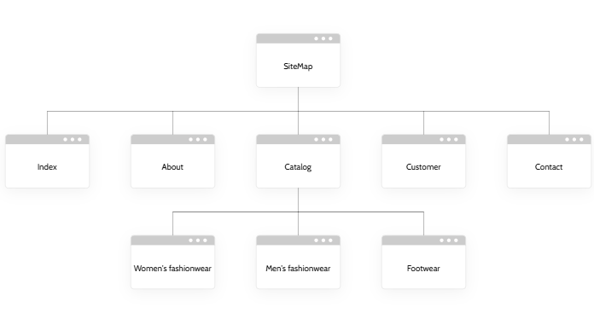
3. Wireframing & Page Blueprinting
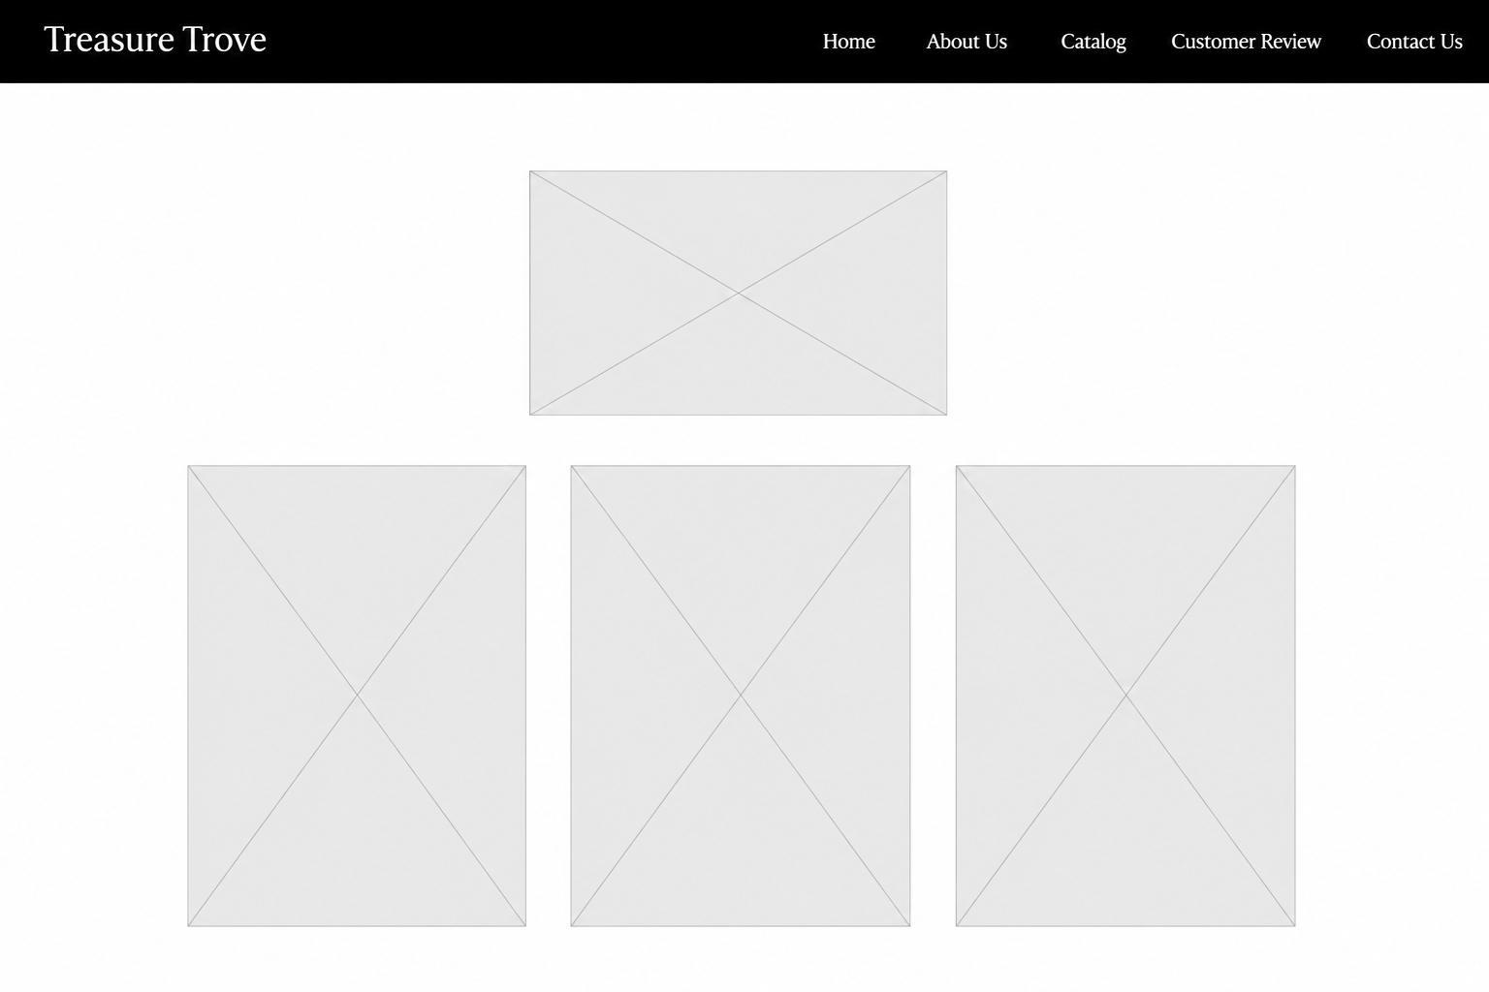

To keep a consistent feel across the whole site, I used a strict global template. This way, navigation stays predictable no matter where someone goes.
The three,part layout:
- Header & Navbar: Every page starts with a high,contrast, dark navigation bar. On mobile, it collapses neatly into a “hamburger” menu to save space.
- Main body: This middle area holds each page’s core content. Even though the info changes, the padding, text sizes, and background colours stay the same across all five pages, so everything feels unified.
- Global footer: Every page ends with a matching minimalist dark banner that handles copyright info consistently.
Component choices:
Instead of slow, clunky iframes (like embedding a Google Form that lags on mobile), I used native framework components:
- Fluid grids: Items flex naturally, stacked on phones, multi,column on desktops.
- Interactive carousels: Multi,image sliders live right inside product containers, keeping layouts compact while letting users swipe through styles and prices.
- Clean HTML: I swapped messy chains of empty <div> tags for semantic elements like <header>, <main>, <section>, and <article>. That keeps the DOM tree clean, speeds up load times, and improves screen reader accessibility.
4. The Production Stack & Technical Choices
I hand,picked modern, lightweight, open,source tools to build this site, so I kept full control over every pixel, transition, and validation script.
- HTML5: The foundation. Semantic elements keep the layout robust, readable, and accessible.
- Custom CSS3: All visual rules live in an external stylesheet (css/style.css). It handles our colour accents, smooth hover effects, and custom borders, giving the store a unique look beyond standard Bootstrap templates.
- Bootstrap v5: Pulled in via CDNs to handle mobile,first grids, spacing utilities, carousels, and the collapsing navigation panel.
- Vanilla JavaScript: A custom script (js/main.js) powers form validation. It handles user input securely and triggers success messages without heavy libraries.
- Visual Studio Code: My environment for writing code, formatting styles, and tracking files.
- GIMP: Used to crop, compress, and size product photos, keeping file sizes small for fast loading on cellular networks.
- GitHub & GitHub Pages: For version history, saving commits, and managing the live deployment.

